PASSWORD STRENGTH ANALYZER
WORKING OF THE SYSTEM:
OUTPUT:
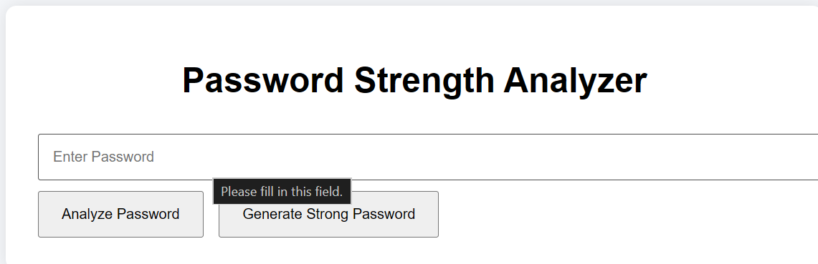
Password strength analyzing:
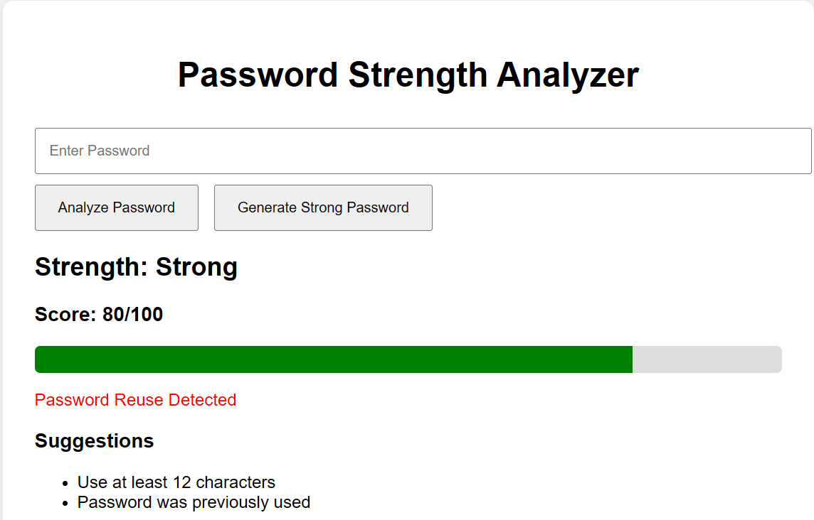
New password generation:
